**PROJECT REPORT TEMPLATE**

1. **INTRODUCTION**
   1. ***OVERVIEW***

India is the world’s third largest producer and third largest consumer of electricity. The national electric grid in India has an installed capacity of 370.106 GW as of 31 March 2020.

Renewable power plants, which also include large hydroelectric plants, constitute 35.86% of India’s total installed capacity.

During the fiscal year (FY) 2019-2020, the total electricity generation in the country was 1,598 TWh, of which 1,383.5 TWh generated by utilities. The gross electricity consumption per capita in FY2019 was 1,208kWh.

* 1. ***PURPOSE***

Electricity generation is the process of generating electric power from sources of primary energy.

For utilities in the electric power industry, it is the stage prior to its delivery to end users or its storage.

.

1. **PROBLEM DEFINITION AND DESIGN THINKING**

***2.1 EMPATHY MAPPING***

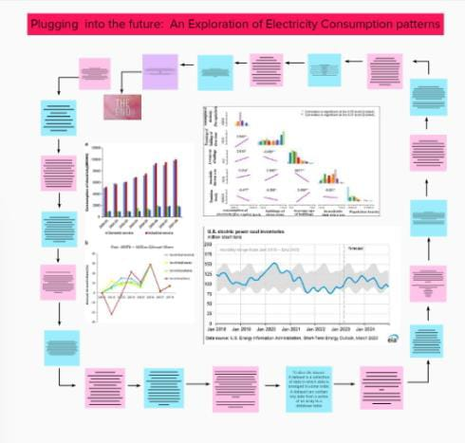

***2.2 IDEATION AND BRAINSTROMING MAP***

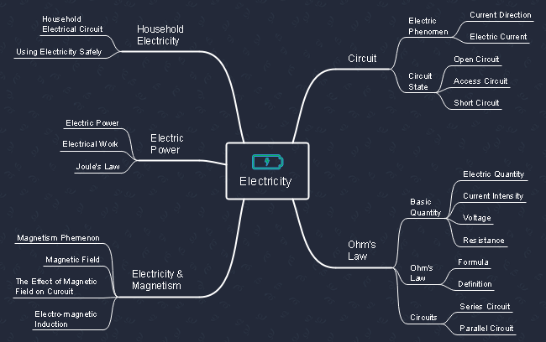

1. **RESULT**

The aim of the project was to identify the variables that influence the generation, the consumption and the price of the electricity around India.

The power sector plays a vital role in the economic growth and development of the country.

1. **ADVANTAGES AND DISADVANTAGES**

|  |  |
| --- | --- |
| ***ADVANTAGES*** | ***DISADVANTAGES*** |
| More efficient | More efficient than gasoline |
| No tailpipe emission | Loss of fish species |
| Reduce greenhouse emission | Dependent on precipitation |
| Relatively low maintenance cost | Cost for construction |
| It is renewable | Drought affect power production |

1. **APPLICATIONS**

People use electricity for lighting,heating,colling and refrigeration and for operating appliances,computers,electronics.

Annual electricity consumption per capita serves as an important measure of a country’s electric power development.

1. **CONCLUSION**

The aim of this project was to identify the variables that influences the generation, the consumption and the price of the electricity in united states.